**ASSIGNMENT 32.3**

Write a Java client API to perform following operations:

● Use HBaseAdmin class and create the table named company with one column family name details.

● Create the method name insert and use put class to insert records to company table.

WRITING A JAVA CODE TO CREATE A TABLE IN HBASE:

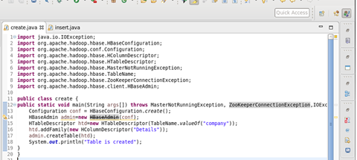

TABLE IS CREATED IN HBASE BY RUNNING THE JAVA CODE (RUN AS APPLICATION) IN ECLIPSE

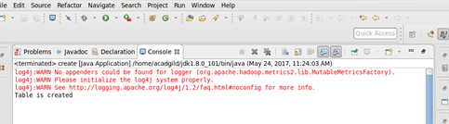

USING ‘LIST’ COMMAND , SHOWING THE TABLES IN HBASE

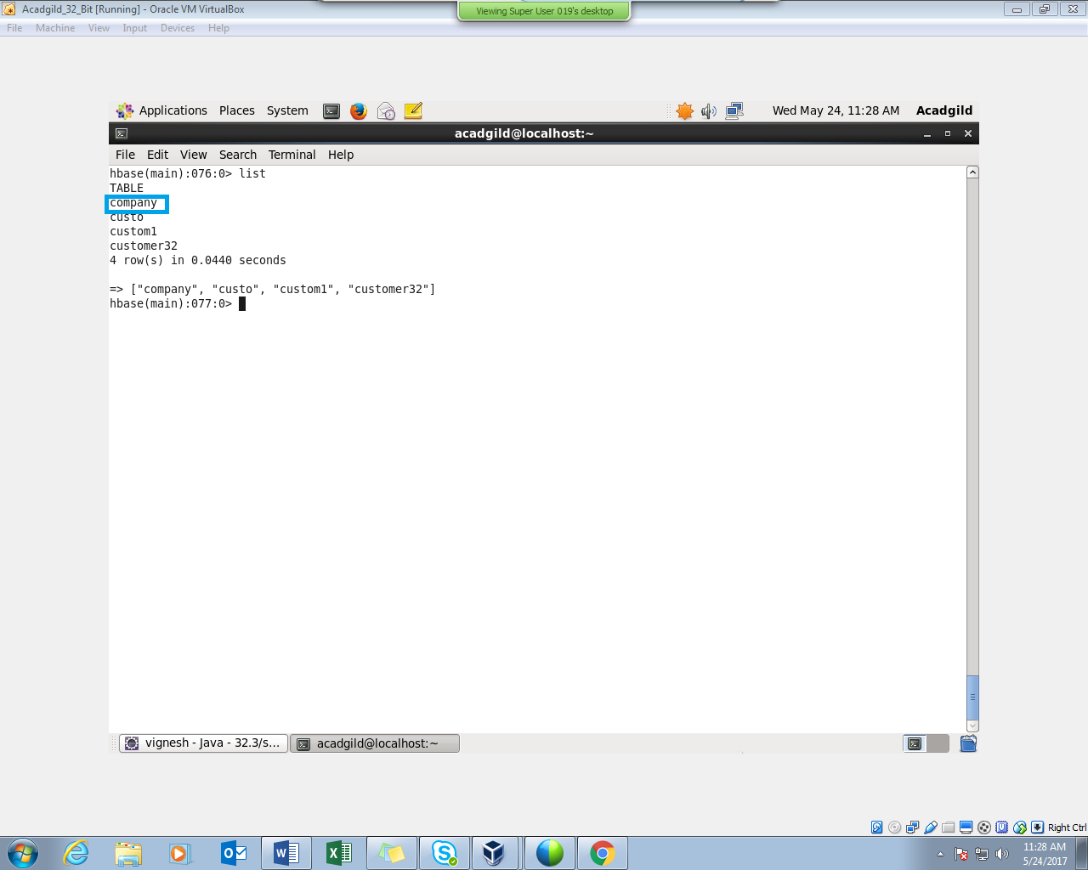

WRITING A JAVA CODE TO INSERT DATA INTO THE TABLE “COMPANY”

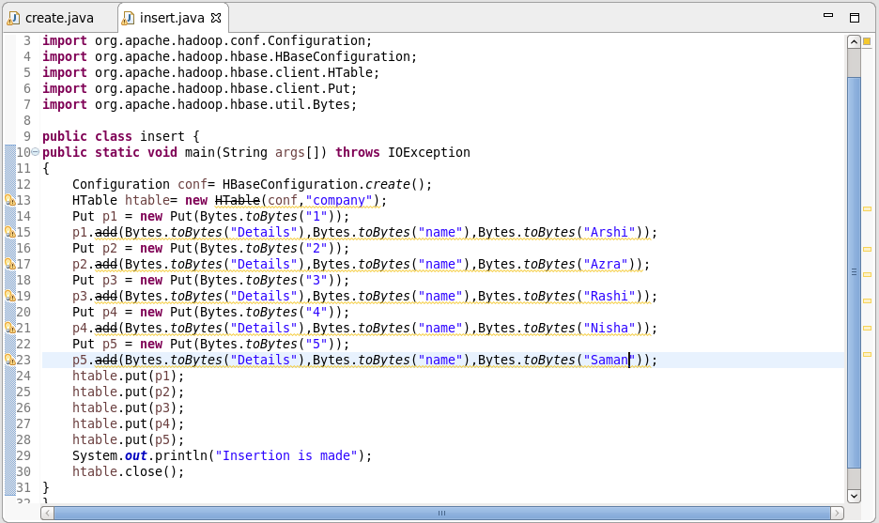

INSERTION IS MADE BY RUNNING THE JAVA CODE IN ECLIPSE (RUN AS APPLICATION)

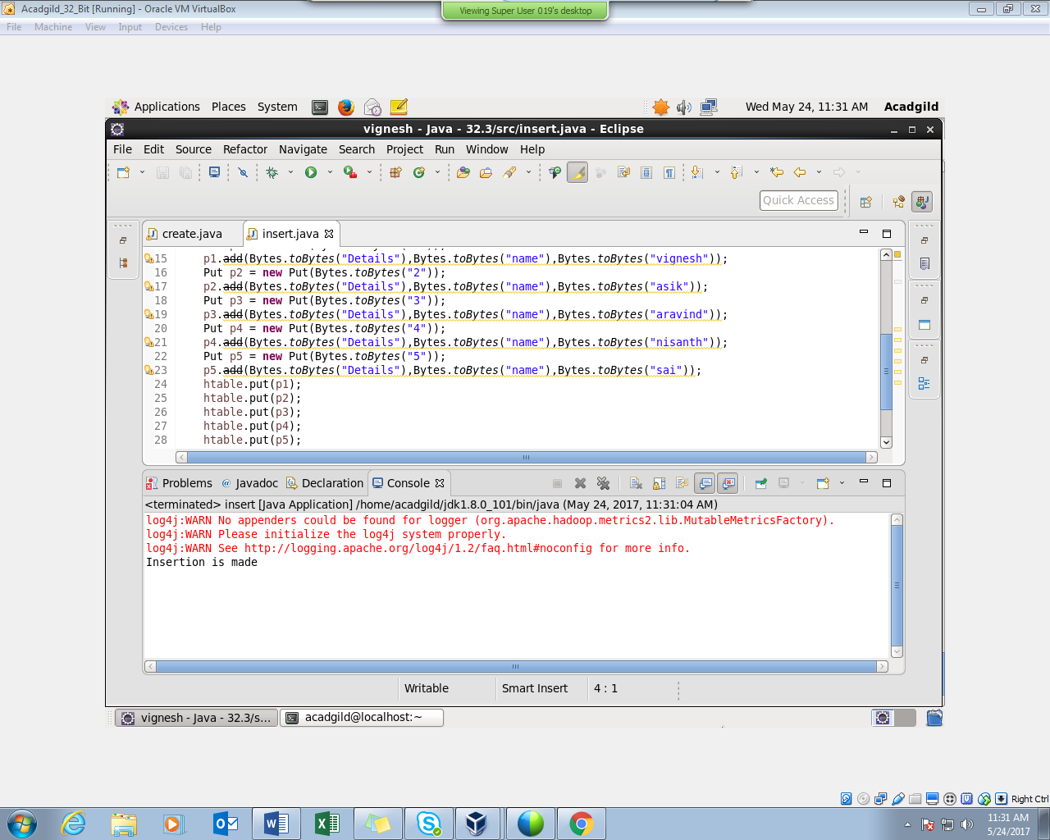

HERE WE CAN SEE THAT INSERTION WAS SUCCESSFUL

PERFORMING SCAN COMMAND :

